GitHub Login & Password Reset – BVA & EP Test Cases
Test Case ID: GH_BVA_EP_01
Webpage URL: https://www.instagram.com

GitHub homepage
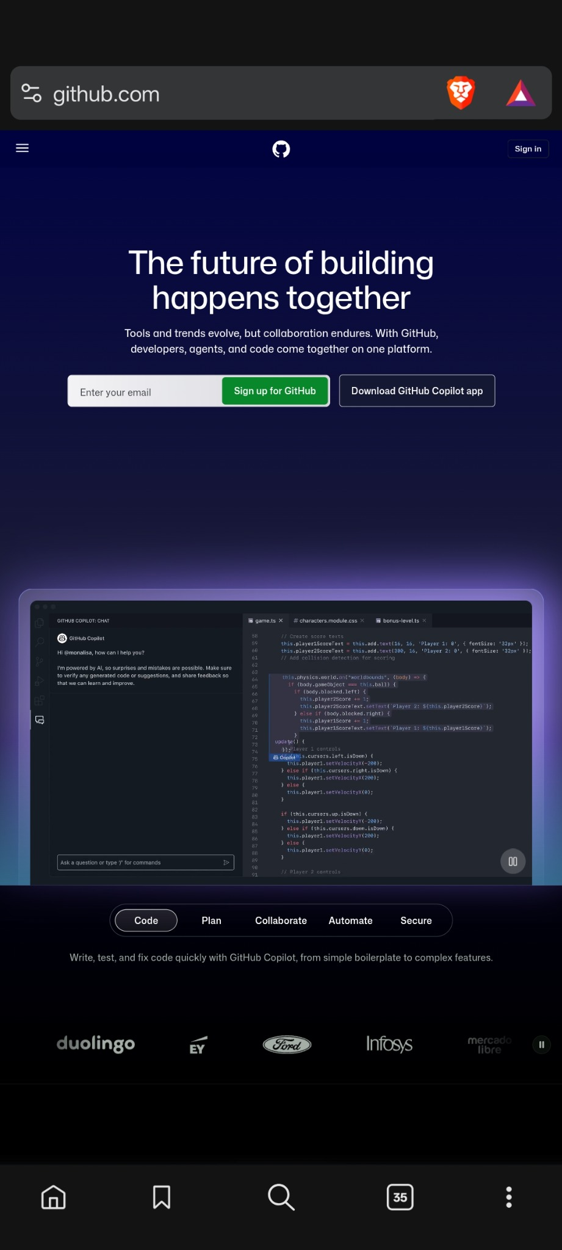

• Scenario ID: TC-01
Scenario: EP – Valid Login
Test Steps:
1. Open GitHub login page.
2. Enter a valid account username/email.
3. Enter the correct password.
4. Click Sign in.
Test Input: Valid username/email + valid password
Expected Results: User should authenticate successfully and enter the account.
Actual Results: No successful-login destination is visible in the supplied evidence.
Status: Not Executed
Comments: Valid equivalence class; use only a test account/synthetic data.
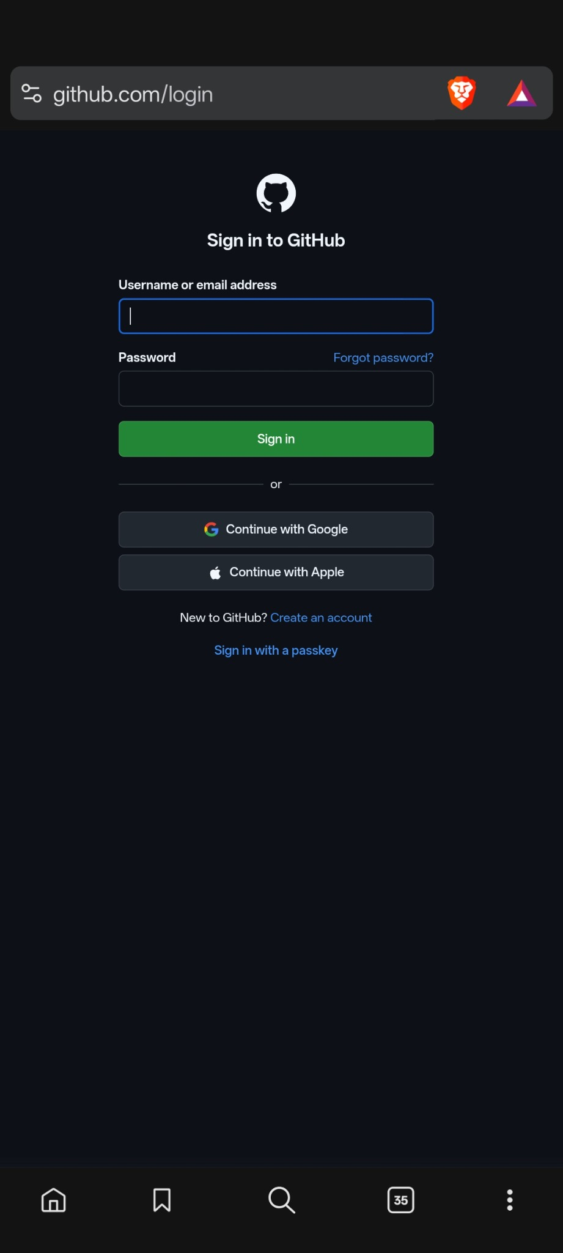

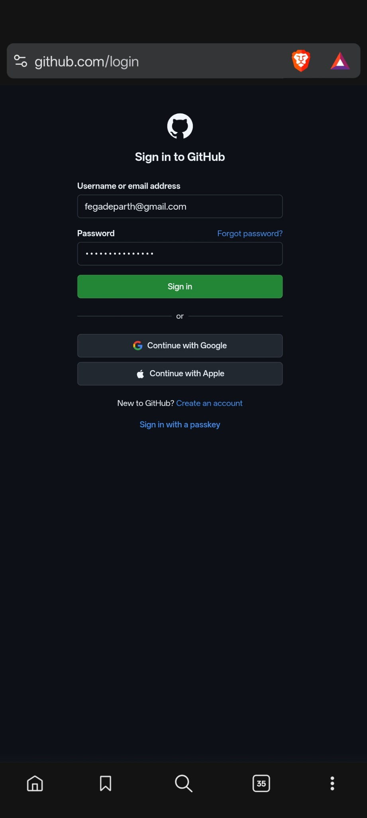

• Scenario ID: TC-02
Scenario: EP – Invalid Login
Test Steps:
1. Open login page.
2. Enter an invalid username/email or incorrect password.
3. Click Sign in.
Test Input: Invalid credentials
Expected Results: A clear authentication error should be displayed and access denied.
Actual Results: “Incorrect username or password.” is displayed.
Status: Pass
Comments: Screenshot 4; Network tab shows POST /session with 401 Unauthorized.
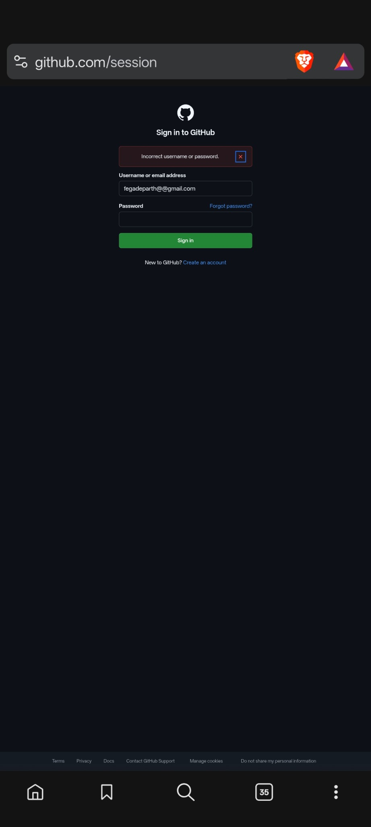
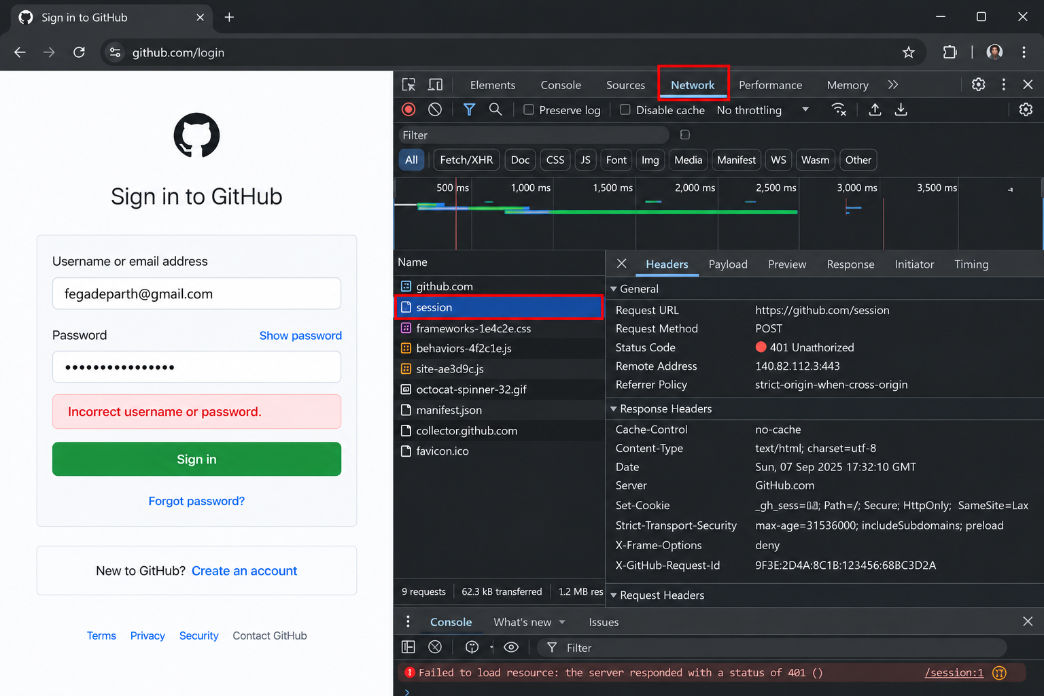

• Scenario ID: TC-03
Scenario: EP – Empty Login Fields
Test Steps:
1. Open login page.
2. Leave username/email blank.
3. Leave password blank.
4. Click Sign in.
Test Input: Blank username/email + blank password
Expected Results: Required-field validation should prevent submission.
Actual Results: Blank login form is shown, but an empty-submit validation result is not supplied.
Status: Not Executed
Comments: Empty/required-field partition identified.

• Scenario ID: TC-04
Scenario: BVA – Password Length 7
Test Steps:
1. Open password-setting form.
2. Enter a 7-character password.
3. Enter matching confirmation.
4. Submit.
Test Input: 7 characters
Expected Results: Password should be rejected below the stated 8-character lower boundary.
Actual Results: Not visibly executed in the supplied screenshots.
Status: Not Executed
Comments: BVA just below the 8-character threshold.

• Scenario ID: TC-05
Scenario: BVA – Password Length 8
Test Steps:
1. Open password-setting form.
2. Enter an 8-character password containing a number and lowercase letter.
3. Confirm it.
4. Submit.
Test Input: 8 characters + number + lowercase
Expected Results: Password should satisfy the shorter stated rule if all other requirements are met.
Actual Results: The form visibly states: at least 15 characters OR at least 8 characters including a number and lowercase letter.
Status: Not Executed
Comments: BVA at the lower valid boundary; evidence is Screenshot 7.
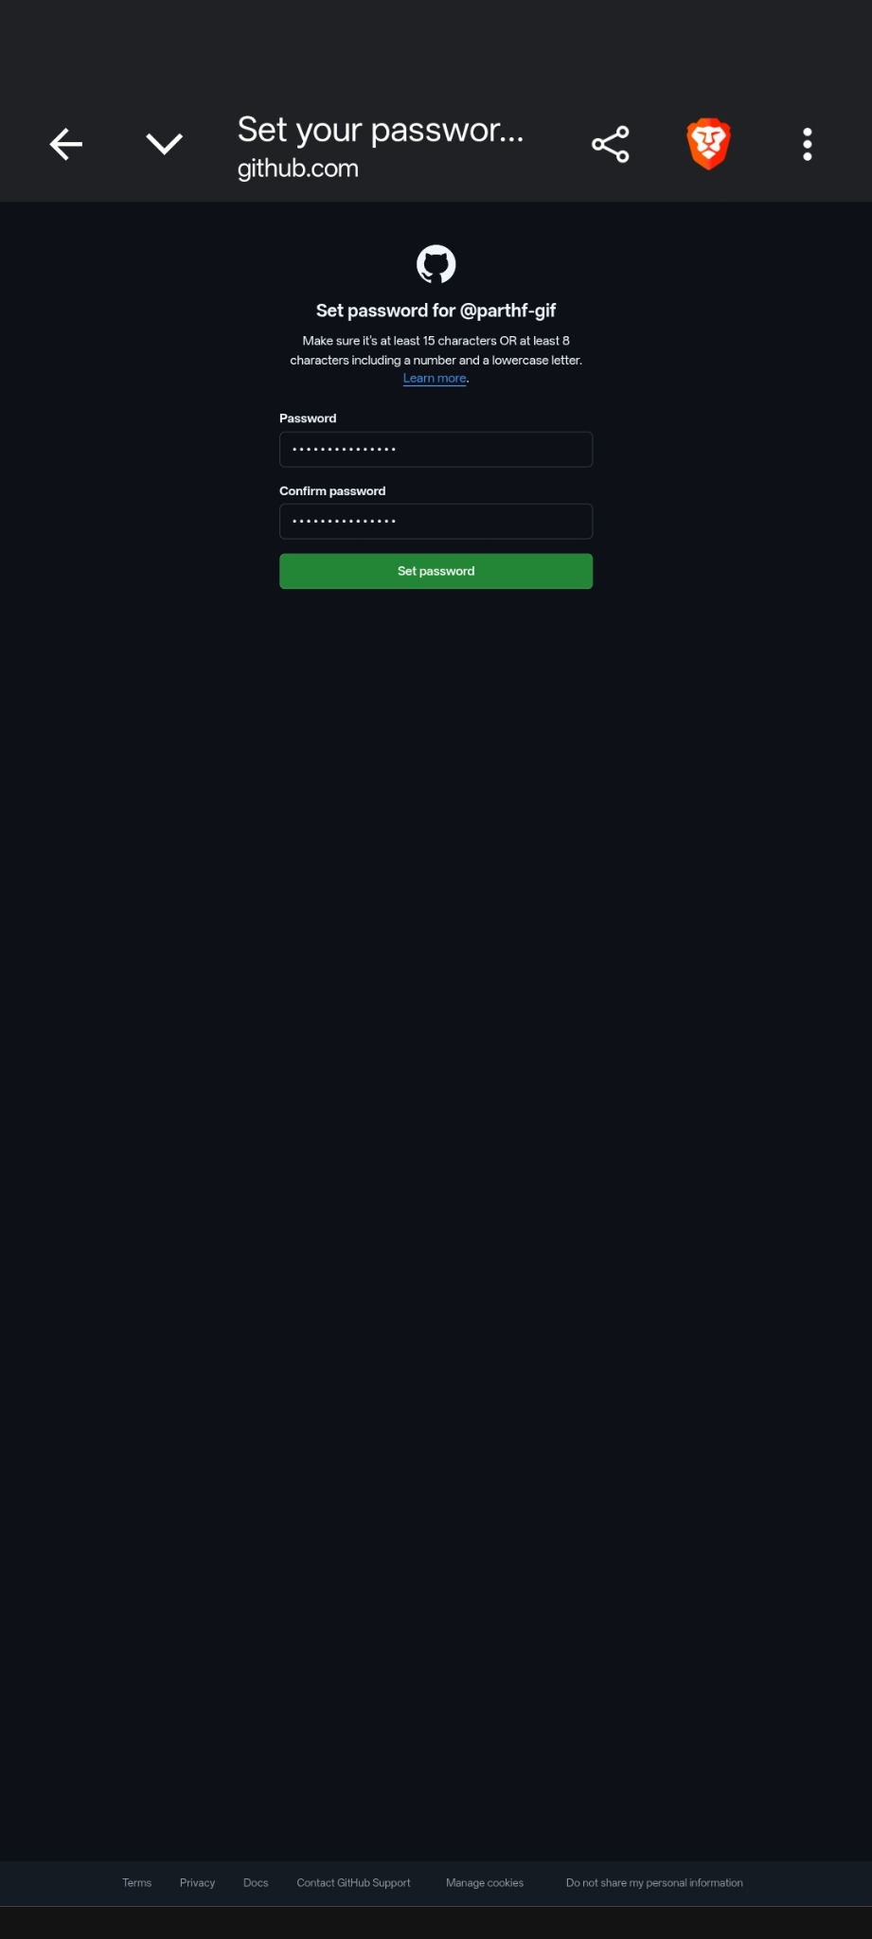

• Scenario ID: TC-06
Scenario: BVA – Password Length 15
Test Steps:
1. Open password-setting form.
2. Enter a compliant 15-character password.
3. Confirm it.
4. Submit.
Test Input: 15 characters
Expected Results: Password should be accepted at the 15-character threshold when compliant.
Actual Results: The stated 15-character threshold is visible, but an isolated 15-character execution is not supplied.
Status: Not Executed
Comments: BVA at the second stated length threshold.

• Scenario ID: TC-07
Scenario: EP – Password Confirmation Match
Test Steps:
1. Enter a new password.
2. Enter the same value in Confirm password.
3. Click Set password.
Test Input: Matching password and confirmation
Expected Results: The two values should match and submission should be allowed.
Actual Results: Both password fields are populated and the Set password button is available.
Status: Pass
Comments: Screenshot 7; characters are masked.

• Scenario ID: TC-08
Scenario: EP – Password Reset Invalid Email
Test Steps:
1. Open Forgot password.
2. Enter an email not associated with an eligible account.
3. Submit.
Test Input: Unverified/non-associated email
Expected Results: A clear error should explain that the address is invalid/not verified/not associated with a personal account.
Actual Results: GitHub displays an error stating that the address is invalid/not a verified primary email or is not associated with a personal user account.
Status: Pass
Comments: Screenshot 9.
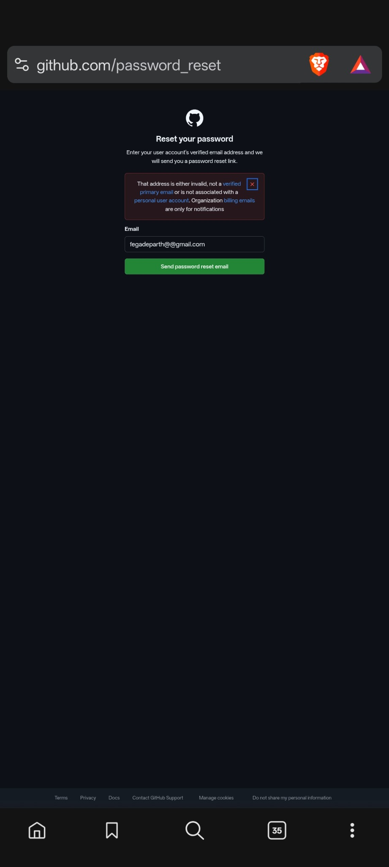

• Scenario ID: TC-09
Scenario: EP – Password Reset Page
Test Steps:
1. Click Forgot password.
2. Observe the reset form.
3. Enter an email address.
Test Input: Email address
Expected Results: Reset form should display an email input and a password-reset submission control.
Actual Results: Reset your password page is displayed with an Email field and Send password reset email button.
Status: Pass
Comments: Screenshot 6.

• Scenario ID: TC-10
Scenario: EP – Successful Password Reset
Test Steps:
1. Use the password-reset flow.
2. Enter a compliant new password and confirmation.
3. Submit.
Test Input: Compliant new password
Expected Results: System should save the new password and return the user to a usable sign-in state.
Actual Results: “New password set successfully.” is displayed on the sign-in page.
Status: Pass
Comments: Screenshot 8.
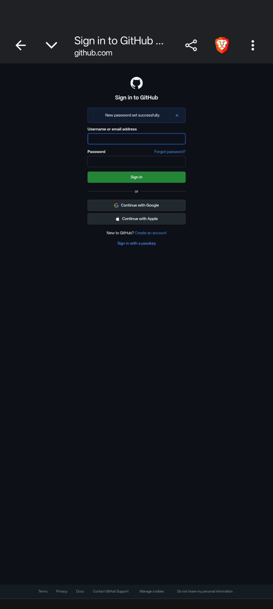

• Summary Of Test Results:
Total Test Cases- 10
Passed- 5
Failed- 0
Not Executed- 5
• Conclusion and Recommendations:
The supplied GitHub test matrix contains 10 test cases. Five are marked Pass and five are marked Not Executed. The supplied evidence documents successful invalid-login handling, password confirmation, invalid-email handling, the password-reset page, and successful password reset. The remaining cases require execution to establish their actual result.
• Issues Found
No test case is marked Failed in the supplied matrix. Cases marked Not Executed should not be treated as passed.
• Recommendations
1. Complete the five Not Executed cases so their actual results can be recorded.
2. Continue using BVA and EP for boundary and invalid-input coverage.
3. Retain screenshot and network evidence for executed authentication cases.
• Bug Reports:
Field | Description
Bug ID | -
Title | No failed test case reported in supplied execution matrix
Module | GitHub Login & Password Reset
Severity | -
Status | N/A – No failed case reported

